Question 1

**Sourcecode**

import java.io.*;  
import java.util.Scanner;  
import java.util.StringTokenizer;  
  
public class student  
{  
 public static void main(String args[])throws IOException  
 {  
 String MatricNumber,StudentName,Program,Gender;  
 double Part=0;  
 int CS110=0,CS111=0;  
   
 try  
 {  
 FileReader fr=new FileReader("FTMSK.txt");  
 BufferedReader br=new BufferedReader(fr);  
   
 FileWriter fw1=new FileWriter("CS110Male.txt");  
 BufferedWriter bw1= new BufferedWriter(fw1);  
 PrintWriter pw1=new PrintWriter(bw1);  
   
 FileWriter fw2=new FileWriter("CS111Male.txt");  
 BufferedWriter bw2= new BufferedWriter(fw2);  
 PrintWriter pw2=new PrintWriter(bw2);  
   
 pw1.println(" Male Students from CS110 \n");  
 pw1.printf("%-20s%-30s%-20s\n","Matric Number","Name","Part");  
 pw2.println(" Male Students from CS111 \n");  
 pw2.printf("%-20s%-30s%-20s\n","Matric Number","Name","Part");  
   
   
 String strLine;  
 while((strLine=br.readLine())!=null)  
 {  
 StringTokenizer data=new StringTokenizer(strLine,";");  
 MatricNumber=data.nextToken();  
 StudentName=data.nextToken();  
 Program=data.nextToken();  
 Part=Integer.parseInt(data.nextToken());  
 Gender=data.nextToken();  
   
 if(Program.equalsIgnoreCase("CS110") && Gender.equalsIgnoreCase("M"))  
 {  
 pw1.printf("%-20s%-30s%-20.0f\n",MatricNumber,StudentName,Part);  
 CS110++;  
 }  
   
 else if(Program.equalsIgnoreCase("CS111") && Gender.equalsIgnoreCase("M"))  
 {  
 pw2.printf("%-20s%-30s%-20.0f\n",MatricNumber,StudentName,Part);  
 CS111++;  
 }  
   
 }  
 pw1.println("Number of male students for CS110 :"+CS110);  
 pw2.println("Number of female students for CS111 :"+CS111);   
   
 br.close();  
 pw1.close();  
 pw2.close();  
 }  
   
   
 catch(FileNotFoundException e)  
 {  
 System.out.println("File Not Found");  
 }  
   
 catch(EOFException e)  
 {  
 System.out.println("Unexpected End of File");  
 }  
   
 catch(NumberFormatException e)  
 {  
 System.out.println("Number Format Incorrect");  
 }  
   
 catch(IOException e)  
 {  
 System.out.println("Input/output Error");  
 }  
 }  
}

**File Input/Output**

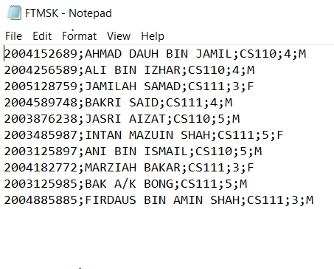

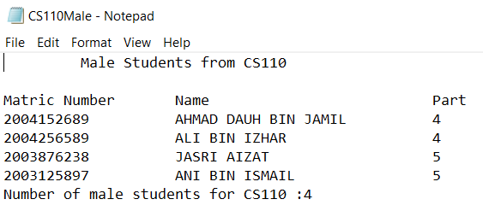

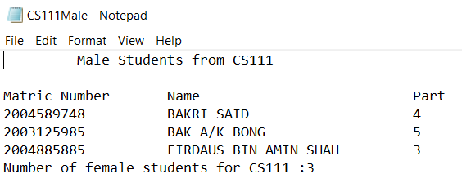

Question 2

**Sourcecode**

**//class Customer**

public class Customer  
{  
 private String name,state,prodId,status;  
 private int quantity;  
   
 public Customer(String nm,String st,String id,int qnty,String stus)  
 {  
 name=nm;  
 state=st;  
 prodId=id;  
 quantity=qnty;  
 status=stus;  
 }  
   
 public String getName(){return name;}  
 public String getState(){return state;}  
 public String getProdId(){return prodId;}  
 public int getQuantity(){return quantity;}  
 public String getStatus(){return status;}  
   
 String prodName;  
 double subtotal,grandtotal,prodPrice,discount,newgrandtotal;  
 public double calcTotal()  
 {  
 if(getProdId().equalsIgnoreCase("101"))  
 {  
 prodName="RAM";  
 prodPrice=200;  
 }  
 else if(getProdId().equalsIgnoreCase("102"))  
 {  
 prodName="Webcam";  
 prodPrice=170;  
 }  
 else if(getProdId().equalsIgnoreCase("103"))  
 {  
 prodName="Printer";  
 prodPrice=350;  
 }  
 else if(getProdId().equalsIgnoreCase("104"))  
 {  
 prodName="External HD";  
 prodPrice=500;  
 }  
   
 subtotal=prodPrice*getQuantity();  
 grandtotal=subtotal+11;  
   
 if(getStatus().equalsIgnoreCase("student"))  
 {  
 discount=grandtotal*0.10;  
 }  
 else if(getStatus().equalsIgnoreCase("Staff"))  
 {  
 discount=0;  
 }  
   
 newgrandtotal=grandtotal-discount;  
 return newgrandtotal;  
  
 }  
   
 public String toString()  
 {  
 return("\nName :"+name+"\nState :"+state+"\nProduct ID :"+prodId+"\nQuantity :"+quantity+"\nStatus :"+status);  
 }  
}

**//class CustomerApp**

import java.io.*;  
import java.util.Scanner;  
import java.util.StringTokenizer;  
  
public class CustomerApp  
{  
 public static void main(String args[])  
 {  
 String nm,st,id,stus;  
 int qnty;  
   
 try  
 {  
 FileReader fr=new FileReader("customer.txt");  
 BufferedReader br=new BufferedReader(fr);  
   
 FileWriter fw1=new FileWriter("staf.txt");  
 BufferedWriter bw1= new BufferedWriter(fw1);  
 PrintWriter staff=new PrintWriter(bw1);  
   
 FileWriter fw2=new FileWriter("student.txt");  
 BufferedWriter bw2= new BufferedWriter(fw2);  
 PrintWriter student=new PrintWriter(bw2);  
   
 String strLine;  
 while((strLine=br.readLine())!=null)  
 {  
 StringTokenizer data=new StringTokenizer(strLine,":");  
 nm=data.nextToken();  
 st=data.nextToken();  
 id=data.nextToken();  
 qnty=Integer.parseInt(data.nextToken());  
 stus=data.nextToken();  
   
 Customer cust=new Customer(nm,st,id,qnty,stus);  
   
 if(cust.getStatus().equalsIgnoreCase("Student"))  
 {  
 student.println(cust.toString());  
 student.println("Grand Total :"+cust.calcTotal());  
 }  
 else if(cust.getStatus().equalsIgnoreCase("Staff"))  
 {  
 staff.println(cust.toString());  
 staff.println("Grand Total :"+cust.calcTotal());  
 }  
  
 }  
 br.close();  
 staff.close();  
 student.close();  
 }  
 catch(FileNotFoundException e)  
 {  
 System.out.println("File Not Found");  
 }  
   
 catch(EOFException e)  
 {  
 System.out.println("Unexpected End of File");  
 }  
   
 catch(NumberFormatException e)  
 {  
 System.out.println("Number Format Incorrect");  
 }  
   
 catch(IOException e)  
 {  
 System.out.println("Input/output Error");  
 }  
  
 }  
}

**File Input/Output**

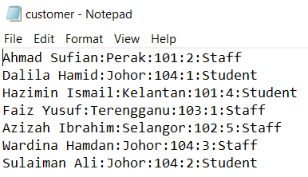

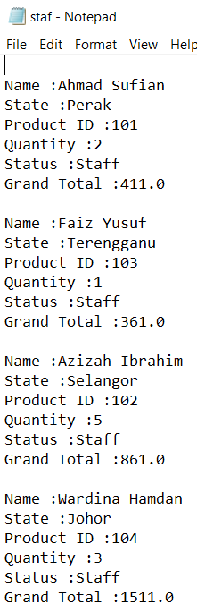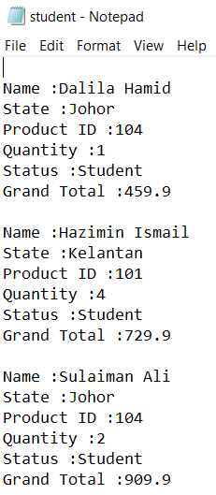

Question 3

**Sourcecode**

import java.io.*;  
import java.util.Scanner;  
import java.util.StringTokenizer;  
  
public class HFMD  
{  
 public static void main(String args[])throws IOException  
 {  
 String state;  
 double c2017=0,c2018=0;  
 int tot2017=0,tot2018=0;  
   
 try  
 {  
 FileReader fr=new FileReader("hfmdcasses.txt");  
 BufferedReader in=new BufferedReader(fr);  
   
 FileWriter fw=new FileWriter("report.txt");  
 BufferedWriter bw= new BufferedWriter(fw);  
 PrintWriter out=new PrintWriter(bw);  
   
 out.println(" HFMD CASES FOR 2017 AND 2018 ");  
 out.printf("%-20s%-20s%-20s\n","STATE","2017","2018");  
   
 String strLine;  
 while((strLine=in.readLine())!=null)  
 {  
 StringTokenizer data=new StringTokenizer(strLine,";");  
 state=data.nextToken();  
 c2017=Double.parseDouble(data.nextToken());  
 c2018=Double.parseDouble(data.nextToken());  
   
 out.printf("%-20s%-20.0f%-20.0f\n",state,c2017,c2018);  
   
 tot2017+=c2017;  
 tot2018+=c2018;  
 }  
 out.println("Total cases for 2017 is "+tot2017);  
 out.println("Total cases for 2018 is "+tot2018);  
   
 in.close();  
 out.close();  
 }  
 catch(FileNotFoundException e)  
 {  
 System.out.println("File Not Found");  
 }  
   
 catch(EOFException e)  
 {  
 System.out.println("Unexpected End of File");  
 }  
   
 catch(NumberFormatException e)  
 {  
 System.out.println("Number Format Incorrect");  
 }  
   
 catch(IOException e)  
 {  
 System.out.println("Input/output Error");  
 }  
 }  
}

**File Input/Output**

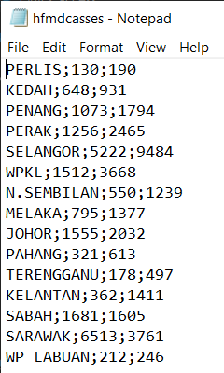

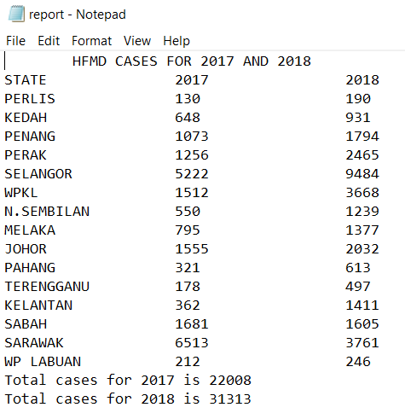



**FACULTY OF COMPUTER SCIENCE AND MATHEMATICS**

**CS110**

Lab Assignment 3 – File Input and Output

NAME: MUHAMMAD AL-AMIN BIN MOHD ZAINI

MATRIC NO: 2018280578

GROUP: RCS1103G

ASSIGNMENT : LAB ASSIGNMENT 3

PROGRAMME CODE: CS110

COURSE CODE: CSC238